**📘 Journevia Documentation Report**

**"Roam. Chronicle. Rewind."*****Copyright © Muhammad Ahmad Sultan***

**1. 🧭 Overview**

**Journevia** is a full-stack MERN (MongoDB, Express.js, React.js, Node.js) application crafted for travel enthusiasts to capture, organize, and relive their travel experiences. It enables users to document adventures through stories enriched with titles, locations, dates, and images, turning memories into a personal travel journal.

Whether you're a solo traveler, a vlogger, or someone who just loves to chronicle places, **Journevia** is your ultimate travel companion.

**2. ✨ Application Highlights**

* 📖 **Chronicle Every Journey**: Seamlessly create and manage personalized travel stories.
* 🖼️ **Multimedia Support**: Attach images to bring stories to life.
* 📅 **Smart Date Logging**: Add and filter stories by travel date.
* 📌 **Favorites Feature**: Pin standout stories for quick access.
* 🔍 **Search & Filter**: Quickly navigate through memories based on keyword or date range.
* 📱 **Responsive & Elegant UI**: Designed for a flawless experience on desktop and mobile alike.

**3. 🔧 Key Features**

A robust and user-friendly travel storytelling app that supports:

**🧑‍💼 User Authentication**

* Secure Login & Signup using JWT
* Password hashing and protected routes
* Persistent session management

**✍️ Travel Story Management**

* Add new stories with:
  + Title
  + Description
  + Travel Date
  + Location (City/Country or Geotag)
  + Story Cover Image
* Edit or delete existing stories
* Mark/unmark favourite stories
* Real-time updates in UI post-action

**🔍 Search & Filtering Capabilities**

* Search stories by keyword in title or description
* Filter stories by custom date range
* Combine filters for advanced exploration

**📸 Image Upload Functionality**

* Upload cover images for each story using Multer
* Images stored and served securely
* Preview images before upload

**💡 UI/UX Features**

* Live feedback and toast messages
* Real-time loading indicators
* Form validation and error highlighting
* Fully responsive layout using modern design trends

**4. 💡 Technologies Used**

**🧩 Frontend – Built with React.js**

* Functional Components and Hooks (useState, useEffect, useContext)
* Custom Components for modular UI (Cards, Modals, Forms)
* Form validation and state management
* Routing with React Router
* Responsive design using:
  + CSS Flexbox/Grid
  + Tailwind CSS or styled-components (your choice)

**🔧 Backend – Powered by Node.js + Express.js**

* RESTful API endpoints
* Middleware-based request handling
* JWT-based authentication
* Multer integration for image uploads
* Environment-based configuration

**🗃️ Database – MongoDB Atlas**

* Cloud-hosted NoSQL database
* Schema design using Mongoose
* Collections:
  + users: Authentication data
  + stories: Travel stories linked to users
* Support for indexing/searching/filtering

**5. 🛠 Backend Feature Breakdown**

|  |  |
| --- | --- |
| **Feature** | **Description** |
| JWT Authentication | Sign up, login, secure routes with token |
| User Authorization | Access limited to logged-in users |
| CRUD APIs | Create, Read, Update, Delete travel stories |
| Image Uploads | Story cover images handled via Multer |
| MongoDB Integration | Cloud database with secure access |

**6. 🌐 Frontend Feature Breakdown**

|  |  |
| --- | --- |
| **Feature** | **Description** |
| Modern React UI | Hook-based, clean and modular |
| Routing | Multi-page navigation using React Router |
| State Management | React Context API or Redux (optional) |
| Form Validation | Input checks before submission |
| Live Feedback | Loaders, success/failure messages |
| Responsive Layout | Mobile-first design, grid/flex layout |

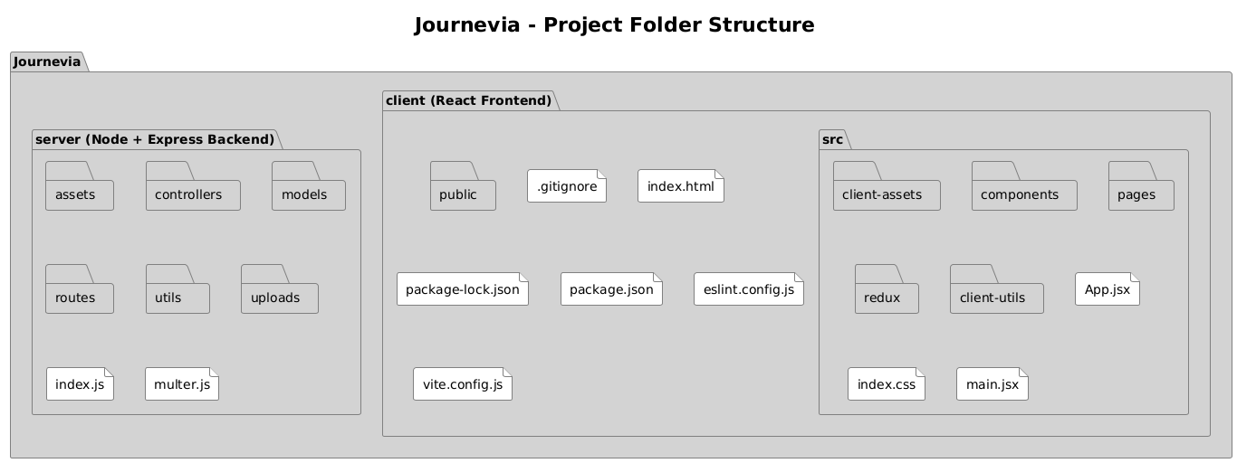**7. 🗂 Folder Structure (Proposed)**

**8. 🛡 Security & Best Practices**

* 🔒 JWT + bcrypt for secure authentication
* 📦 Environment variables for secrets and config
* 📁 Protected image uploads with access control
* ⚙️ API rate limiting (optional future enhancement)
* 🧪 Validation & sanitization of user input

**9. 🔮 Future Enhancements**

* 🌍 Map Integration (e.g., Google Maps) to geotag stories
* 🧑‍🤝‍🧑 Social Sharing or Public Profiles
* 🗺️ Travel Route Visualization on Map
* 🧠 AI-generated summaries of travel stories
* 🌐 PWA Support for offline access

**10. 🎯 Final Thoughts**

**Journevia** is more than just a travel diary, it’s a digital keepsake box that makes your memories accessible, meaningful, and beautifully presented.

Whether you're a frequent flyer or a casual explorer, Journevia empowers you to document your adventures in your own words, images, and time.

***Let your travels tell the story.******Let Journevia be the storyteller.***